Chapter 05
Introduction to Valuation: The Time Value of Money

Multiple Choice Questions
1. You are investing $100 today in a savings account at your local bank. Which one of the following terms refers to the value of this investment one year from now?
A. future value
B. present value
C. principal amounts
D. discounted value
E. invested principal

2. Tracy invested $1,000 five years ago and earns 4 percent interest on her investment. By leaving her interest earnings in her account, she increases the amount of interest she earns each year. The way she is handling her interest income is referred to as which one of the following?
A. simplifying
B. compounding
C. aggregation
D. accumulation
E. discounting

3. Steve invested $100 two years ago at 10 percent interest. The first year, he earned $10 interest on his $100 investment. He reinvested the $10. The second year, he earned $11 interest on his $110 investment. The extra $1 he earned in interest the second year is referred to as:
A. free interest.
B. bonus income.
C. simple interest.
D. interest on interest.
E. present value interest.

4. Interest earned on both the initial principal and the interest reinvested from prior periods is called:
A. free interest.
B. dual interest.
C. simple interest.
D. interest on interest.
E. compound interest.

5. Sara invested $500 six years ago at 5 percent interest. She spends her earnings as soon as she earns any interest so she only receives interest on her initial $500 investment. Which type of interest is Sara earning?
A. free interest
B. complex interest
C. simple interest
D. interest on interest
E. compound interest

6. Shelley won a lottery and will receive $1,000 a year for the next ten years. The value of her winnings today discounted at her discount rate is called which one of the following?
A. single amount
B. future value
C. present value
D. simple amount
E. compounded value

7. Terry is calculating the present value of a bonus he will receive next year. The process he is using is called:
A. growth analysis.
B. discounting.
C. accumulating.
D. compounding.
E. reducing.

8. Steve just computed the present value of a $10,000 bonus he will receive in the future. The interest rate he used in this process is referred to as which one of the following?
A. current yield
B. effective rate
C. compound rate
D. simple rate
E. discount rate

9. The process of determining the present value of future cash flows in order to know their worth today is called which one of the following?
A. compound interest valuation
B. interest on interest computation
C. discounted cash flow valuation
D. present value interest factoring
E. complex factoring

10. Andy deposited $3,000 this morning into an account that pays 5 percent interest, compounded annually. Barb also deposited $3,000 this morning into an account that pays 5 percent interest, compounded annually. Andy will withdraw his interest earnings and spend it as soon as possible. Barb will reinvest her interest earnings into her account. Given this, which one of the following statements is true?
A. Barb will earn more interest the first year than Andy will.
B. Andy will earn more interest in year three than Barb will.
C. Barb will earn interest on interest.
D. After five years, Andy and Barb will both have earned the same amount of interest.
E. Andy will earn compound interest.

11. Sue and Neal are twins. Sue invests $5,000 at 7 percent when she is 25 years old. Neal invests $5,000 at 7 percent when he is 30 years old. Both investments compound interest annually. Both Sue and Neal retire at age 60. Which one of the following statements is correct assuming that neither Sue nor Neal has withdrawn any money from their accounts?
A. Sue will have less money when she retires than Neal.
B. Neal will earn more interest on interest than Sue.
C. Neal will earn more compound interest than Sue.
D. If both Sue and Neal wait to age 70 to retire, then they will have equal amounts of savings.
E. Sue will have more money than Neal as long as they retire at the same time.

12. Samantha opened a savings account this morning. Her money will earn 5 percent interest, compounded annually. After five years, her savings account will be worth $5,600. Assume she will not make any withdrawals. Given this, which one of the following statements is true?
A. Samantha deposited more than $5,600 this morning.
B. The present value of Samantha's account is $5,600.
C. Samantha could have deposited less money and still had $5,600 in five years if she could have earned 5.5 percent interest.
D. Samantha would have had to deposit more money to have $5,600 in five years if she could have earned 6 percent interest.
E. Samantha will earn an equal amount of interest every year for the next five years.

13. This afternoon, you deposited $1,000 into a retirement savings account. The account will compound interest at 6 percent annually. You will not withdraw any principal or interest until you retire in forty years. Which one of the following statements is correct?
A. The interest you earn six years from now will equal the interest you earn ten years from now.
B. The interest amount you earn will double in value every year.
C. The total amount of interest you will earn will equal $1,000  .06  40.
D. The present value of this investment is equal to $1,000.
E. The future value of this amount is equal to $1,000  (1 + 40)^{.06}.

14. Your grandmother has promised to give you $5,000 when you graduate from college. She is expecting you to graduate two years from now. What happens to the present value of this gift if you delay your graduation by one year and graduate three years from now?
A. remains constant
B. increases
C. decreases
D. becomes negative
E. cannot be determined from the information provided

15. Luis is going to receive $20,000 six years from now. Soo Lee is going to receive $20,000 nine years from now. Which one of the following statements is correct if both Luis and Soo Lee apply a 7 percent discount rate to these amounts?
A. The present values of Luis and Soo Lee's monies are equal.
B. In future dollars, Soo Lee's money is worth more than Luis' money.
C. In today's dollars, Luis' money is worth more than Soo Lee's.
D. Twenty years from now, the value of Luis' money will be equal to the value of Soo Lee's money.
E. Soo Lee's money is worth more than Luis' money given the 7 percent discount rate.

16. Which one of the following variables is the exponent in the present value formula?
A. present value
B. future value
C. interest rate
D. time
E. There is no exponent in the present value formula.

17. You want to have $1 million in your savings account when you retire. You plan on investing a single lump sum today to fund this goal. You are planning on investing in an account which will pay 7.5 percent annual interest. Which of the following will reduce the amount that you must deposit today if you are to have your desired $1 million on the day you retire?
I. Invest in a different account paying a higher rate of interest.
II. Invest in a different account paying a lower rate of interest.
III. Retire later.
IV. Retire sooner.
A. I only
B. II only
C. I and III only
D. I and IV only
E. II and III only

18. Which one of the following will produce the highest present value interest factor?
A. 6 percent interest for five years
B. 6 percent interest for eight years
C. 6 percent interest for ten years
D. 8 percent interest for five years
E. 8 percent interest for ten years

19. What is the relationship between present value and future value interest factors?
A. The present value and future value factors are equal to each other.
B. The present value factor is the exponent of the future value factor.
C. The future value factor is the exponent of the present value factor.
D. The factors are reciprocals of each other.
E. There is no relationship between these two factors.

20. Martin invested $1,000 six years ago and expected to have $1,500 today. He has not added or withdrawn any money from this account since his initial investment. All interest was reinvested in the account. As it turns out, Martin only has $1,420 in his account today. Which one of the following must be true?
A. Martin earned simple interest rather than compound interest.
B. Martin earned a lower interest rate than he expected.
C. Martin did not earn any interest on interest as he expected.
D. Martin ignored the Rule of 72 which caused his account to decrease in value.
E. The future value interest factor turned out to be higher than Martin expected.

21. Gerold invested $6,200 in an account that pays 5 percent simple interest. How much money will he have at the end of ten years?
A. $8,710
B. $9,000
C. $9,300
D. $9,678
E. $10,099

22. Alex invested $10,500 in an account that pays 6 percent simple interest. How much money will he have at the end of four years?
A. $12,650
B. $12,967
C. $13,020
D. $13,256
E. $13,500

23. You invested $1,650 in an account that pays 5 percent simple interest. How much more could you have earned over a 20-year period if the interest had compounded annually?
A. $849.22
B. $930.11
C. $982.19
D. $1,021.15
E. $1,077.94

24. Travis invested $9,250 in an account that pays 6 percent simple interest. How much more could he have earned over a 7-year period if the interest had compounded annually?
A. $741.41
B. $773.58
C. $802.16
D. $833.33
E. $858.09

25. What is the future value of $7,189 invested for 23 years at 9.25 percent compounded annually?
A. $22,483.60
B. $27,890.87
C. $38,991.07
D. $51,009.13
E. $54,999.88

26. Today, you earn a salary of $36,000. What will be your annual salary twelve years from now if you earn annual raises of 3.6 percent?
A. $55,032.54
B. $57,414.06
C. $58,235.24
D. $59,122.08
E. $59,360.45

27. You own a classic automobile that is currently valued at $147,900. If the value increases by 6.5 percent annually, how much will the automobile be worth ten years from now?
A. $244,035.00
B. $251,008.17
C. $270,013.38
D. $277,628.63
E. $291,480.18

28. You hope to buy your dream car four years from now. Today, that car costs $82,500. You expect the price to increase by an average of 4.8 percent per year over the next four years. How much will your dream car cost by the time you are ready to buy it?
A. $98,340.00
B. $98,666.67
C. $99,517.41
D. $99,818.02
E. $100,023.16

29. This morning, TL Trucking invested $80,000 to help fund a company expansion project planned for 4 years from now. How much additional money will the firm have 4 years from now if it can earn 5 percent rather than 4 percent on its savings?
A. $2,940.09
B. $3,651.82
C. $4,008.17
D. $4,219.68
E. $4,711.08

30. You just received $225,000 from an insurance settlement. You have decided to set this money aside and invest it for your retirement. Currently, your goal is to retire 25 years from today. How much more will you have in your account on the day you retire if you can earn an average return of 10.5 percent rather than just 8 percent?
A. $417,137
B. $689,509
C. $1,050,423
D. $1,189,576
E. $1,818,342

31. You just received a $5,000 gift from your grandmother. You have decided to save this money so that you can gift it to your grandchildren 50 years from now. How much additional money will you have to gift to your grandchildren if you can earn an average of 8.5 percent instead of just 8 percent on your savings?
A. $47,318.09
B. $52,464.79
C. $55,211.16
D. $58,811.99
E. $60,923.52

32. You are depositing $1,500 in a retirement account today and expect to earn an average return of 7.5 percent on this money. How much additional income will you earn if you leave the money invested for 45 years instead of just 40 years?
A. $10,723.08
B. $11,790.90
C. $12,441.56
D. $12,908.19
E. $13,590.93

33. You collect old coins. Today, you have two coins each of which is valued at $250. One coin is expected to increase in value by 6 percent annually while the other coin is expected to increase in value by 4.5 percent annually. What will be the difference in the value of the two coins 15 years from now?
A. $115.32
B. $208.04
C. $241.79
D. $254.24
E. $280.15

34. Your father invested a lump sum 26 years ago at 4.25 percent interest. Today, he gave you the proceeds of that investment which totaled $51,480.79. How much did your father originally invest?
A. $15,929.47
B. $16,500.00
C. $17,444.86
D. $17,500.00
E. $17,999.45

35. What is the present value of $150,000 to be received 8 years from today if the discount rate is 11 percent?
A. $65,088.97
B. $71,147.07
C. $74,141.41
D. $79,806.18
E. $83,291.06

36. You would like to give your daughter $75,000 towards her college education 17 years from now. How much money must you set aside today for this purpose if you can earn 8 percent on your investments?
A. $18,388.19
B. $20,270.17
C. $28,417.67
D. $29,311.13
E. $32,488.37

37. You want to have $35,000 saved 6 years from now to buy a house. How much less do you have to deposit today to reach this goal if you can earn 5.5 percent rather than 5 percent on your savings? Today's deposit is the only deposit you will make to this savings account.
A. $733.94
B. $791.18
C. $824.60
D. $845.11
E. $919.02

38. Your older sister deposited $5,000 today at 8.5 percent interest for 5 years. You would like to have just as much money at the end of the next 5 years as your sister will have. However, you can only earn 7 percent interest. How much more money must you deposit today than your sister did if you are to have the same amount at the end of the 5 years?
A. $321.19
B. $360.43
C. $387.78
D. $401.21
E. $413.39

39. A year ago, you deposited $30,000 into a retirement savings account at a fixed rate of 5.5 percent. Today, you could earn a fixed rate of 6.5 percent on a similar type account. However, your rate is fixed and cannot be adjusted. How much less could you have deposited last year if you could have earned a fixed rate of 6.5 percent and still have the same amount as you currently will when you retire 38 years from today?
A. $2,118.42 less
B. $3,333.33 less
C. $5,417.09 less
D. $7,274.12 less
E. $9,234.97 less

40. When you retire 40 years from now, you want to have $1.2 million. You think you can earn an average of 12 percent on your investments. To meet your goal, you are trying to decide whether to deposit a lump sum today, or to wait and deposit a lump sum 2 years from today. How much more will you have to deposit as a lump sum if you wait for 2 years before making the deposit?
A. $1,414.14
B. $2,319.47
C. $2,891.11
D. $3,280.78
E. $3,406.78

41. Theo needs $40,000 as a down payment for a house 6 years from now. He earns 3.5 percent on his savings. Theo can either deposit one lump sum today for this purpose or he can wait a year and deposit a lump sum. How much additional money must he deposit if he waits for one year rather than making the deposit today?
A. $878.98
B. $911.13
C. $1,138.90
D. $1,348.03
E. $1,420.18

42. One year ago, you invested $1,800. Today it is worth $1,924.62. What rate of interest did you earn?
A. 6.59 percent
B. 6.67 percent
C. 6.88 percent
D. 6.92 percent
E. 7.01 percent

43. According to the Rule of 72, you can do which one of the following?
A. double your money in five years at 7.2 percent interest
B. double your money in 7.2 years at 8 percent interest
C. double your money in 8 years at 9 percent interest
D. triple your money in 7.2 years at 5 percent interest
E. triple your money at 10 percent interest in 7.2 years

44. Forty years ago, your mother invested $5,000. Today, that investment is worth $430,065.11. What is the average annual rate of return she earned on this investment?
A. 11.68 percent
B. 11.71 percent
C. 11.78 percent
D. 11.91 percent
E. 12.02 percent

45. Sixteen years ago, Alicia invested $1,000. Eight years ago, Travis invested $2,000. Today, both Alicia's and Travis' investments are each worth $2,400. Assume that both Alicia and Travis continue to earn their respective rates of return. Which one of the following statements is correct concerning these investments?
A. Three years from today, Travis' investment will be worth more than Alicia's.
B. One year ago, Alicia's investment was worth less than Travis' investment.
C. Travis earns a higher rate of return than Alicia.
D. Travis has earned an average annual interest rate of 3.37 percent.
E. Alicia has earned an average annual interest rate of 6.01 percent.

46. Penn Station is saving money to build a new loading platform. Two years ago, they set aside $24,000 for this purpose. Today, that account is worth $28,399. What rate of interest is Penn Station earning on this investment?
A. 6.39 percent
B. 7.47 percent
C. 8.78 percent
D. 9.23 percent
E. 9.67 percent

47. Fifteen years ago, Jackson Supply set aside $130,000 in case of a financial emergency. Today, that account has increased in value to $330,592. What rate of interest is the firm earning on this money?
A. 5.80 percent
B. 6.42 percent
C. 6.75 percent
D. 7.28 percent
E. 7.53 percent

48. Fourteen years ago, your parents set aside $7,500 to help fund your college education. Today, that fund is valued at $26,180. What rate of interest is being earned on this account?
A. 7.99 percent
B. 8.36 percent
C. 8.51 percent
D. 9.34 percent
E. 10.06 percent

49. Some time ago, Julie purchased eleven acres of land costing $36,900. Today, that land is valued at $214,800. How long has she owned this land if the price of the land has been increasing at 10.5 percent per year?
A. 13.33 years
B. 16.98 years
C. 17.64 years
D. 19.29 years
E. 21.08 years

50. On your ninth birthday, you received $300 which you invested at 4.5 percent interest, compounded annually. Your investment is now worth $756. How old are you today?
A. age 29
B. age 30
C. age 31
D. age 32
E. age 33

Essay Questions
51. You want to deposit sufficient money today into a savings account so that you will have $1,000 in the account three years from today. Explain why you could deposit less money today if you could earn 3.5 percent interest rather than 3 percent interest.

52. You are considering two separate investments. Both investments pay 7 percent interest. Investment A pays simple interest and Investment B pays compound interest. Which investment should you choose, and why, if you plan on investing for a period of 5 years?

53. What lesson does the future value formula provide for young workers who are looking ahead to retiring some day?

54. You are considering two lottery payment options: Option A pays $10,000 today and Option B pays $20,000 at the end of ten years. Assume you can earn 6 percent on your savings. Which option will you choose if you base your decision on present values? Which option will you choose if you base your decision on future values? Explain why your answers are either the same or different.

55. At an interest rate of 10 percent and using the Rule of 72, how long will it take to double the value of a lump sum invested today? How long will it take after that until the account grows to four times the initial investment? Given the power of compounding, shouldn't it take less time for the money to double the second time?

Multiple Choice Questions
56. Assume the total cost of a college education will be $300,000 when your child enters college in 16 years. You presently have $75,561 to invest. What rate of interest must you earn on your investment to cover the cost of your child's college education?
A. 7.75 percent
B. 8.50 percent
C. 9.00 percent
D. 9.25 percent
E. 9.50 percent

57. At 11 percent interest, how long would it take to quadruple your money?
A. 6.55 years
B. 6.64 years
C. 13.09 years
D. 13.28 years
E. 13.56 years

58. Assume the average vehicle selling price in the United States last year was $41,996. The average price 9 years earlier was $29,000. What was the annual increase in the selling price over this time period?
A. 3.89 percent
B. 4.20 percent
C. 4.56 percent
D. 5.01 percent
E. 5.40 percent

59. You're trying to save to buy a new $160,000 Ferrari. You have $56,000 today that can be invested at your bank. The bank pays 6 percent annual interest on its accounts. How many years will it be before you have enough to buy the car? Assume the price of the car remains constant.
A. 16.67 years
B. 17.04 years
C. 17.41 years
D. 17.87 years
E. 18.02 years

60. Imprudential, Inc. has an unfunded pension liability of $850 million that must be paid in 25 years. To assess the value of the firm's stock, financial analysts want to discount this liability back to the present. The relevant discount rate is 6.5 percent. What is the present value of this liability?
A. $159,803,162
B. $171,438,907
C. $176,067,311
D. $184,519,484
E. $191,511,367

61. You have just received notification that you have won the $1.4 million first prize in the Centennial Lottery. However, the prize will be awarded on your 100th birthday, 70 years from now. The appropriate discount rate is 8 percent. What is the present value of your winnings?
A. $4,288.16
B. $6,404.20
C. $15,309.91
D. $23,333.33
E. $25,000.00

62. Your coin collection contains fifty-four 1941 silver dollars. Your grandparents purchased them for their face value when they were new. These coins have appreciated at a 10 percent annual rate. How much will your collection be worth when you retire in 2060?
A. $3,611,008
B. $3,987,456
C. $4,122,394
D. $4,421,008
E. $4,551,172

63. In 1895, the winner of a competition was paid $110. In 2006, the winner's prize was $70,000. What will the winner's prize be in 2040 if the prize continues increasing at the same rate?
A. $389,400
B. $421,122
C. $479,311
D. $505,697
E. $548,121

64. Suppose that the first comic book of a classic series was sold in 1954. In 2000, the estimated price for this comic book in good condition was about $340,000. This represented a return of 27 percent per year. For this to be true, what was the original price of the comic book in 1954?
A. $5.00
B. $5.28
C. $5.50
D. $5.71
E. $6.00

65. Suppose you are committed to owning a $140,000 Ferrari. You believe your mutual fund can achieve an annual rate of return of 9 percent and you want to buy the car in 7 years. How much must you invest today to fund this purchase assuming the price of the car remains constant?
A. $74,208.16
B. $76,584.79
C. $77,911.08
D. $78,019.82
E. $79,446.60

66. You have just made a $1,500 contribution to your individual retirement account. Assume you earn a 12 percent rate of return and make no additional contributions. How much more will your account be worth when you retire in 25 years than it would be if you waited another 10 years before making this contribution?
A. $8,306.16
B. $9,658.77
C. $16,311.18
D. $16,907.17
E. $17,289.75

67. You are scheduled to receive $30,000 in two years. When you receive it, you will invest it for 5 more years, at 8 percent per year. How much money will you have 7 years from now?
A. $39,909.19
B. $41,381.16
C. $44,079.84
D. $47,209.19
E. $51,414.73

68. You expect to receive $9,000 at graduation in 2 years. You plan on investing this money at 10 percent until you have $60,000. How many years will it be until this occurs?
A. 18.78 years
B. 19.96 years
C. 21.90 years
D. 23.08 years
E. 25.00 years

Chapter 05 Introduction to Valuation: The Time Value of Money Answer Key

Multiple Choice Questions
1. You are investing $100 today in a savings account at your local bank. Which one of the following terms refers to the value of this investment one year from now?
A. future value
B. present value
C. principal amounts
D. discounted value
E. invested principal
Refer to section 5.1

AACSB: N/A
Bloom's: Knowledge
Difficulty: Basic
Learning Objective: 5-1
Section: 5.1
Topic: Future value
2. Tracy invested $1,000 five years ago and earns 4 percent interest on her investment. By leaving her interest earnings in her account, she increases the amount of interest she earns each year. The way she is handling her interest income is referred to as which one of the following?
A. simplifying
B. compounding
C. aggregation
D. accumulation
E. discounting
Refer to section 5.1

AACSB: N/A
Bloom's: Knowledge
Difficulty: Basic
Learning Objective: 5-1
Section: 5.1
Topic: Compounding
3. Steve invested $100 two years ago at 10 percent interest. The first year, he earned $10 interest on his $100 investment. He reinvested the $10. The second year, he earned $11 interest on his $110 investment. The extra $1 he earned in interest the second year is referred to as:
A. free interest.
B. bonus income.
C. simple interest.
D. interest on interest.
E. present value interest.
Refer to section 5.1

AACSB: N/A
Bloom's: Knowledge
Difficulty: Basic
Learning Objective: 5-1
Section: 5.1
Topic: Interest on interest
4. Interest earned on both the initial principal and the interest reinvested from prior periods is called:
A. free interest.
B. dual interest.
C. simple interest.
D. interest on interest.
E. compound interest.
Refer to section 5.1

AACSB: N/A
Bloom's: Knowledge
Difficulty: Basic
Learning Objective: 5-1
Section: 5.1
Topic: Compound interest
5. Sara invested $500 six years ago at 5 percent interest. She spends her earnings as soon as she earns any interest so she only receives interest on her initial $500 investment. Which type of interest is Sara earning?
A. free interest
B. complex interest
C. simple interest
D. interest on interest
E. compound interest
Refer to section 5.1

AACSB: N/A
Bloom's: Knowledge
Difficulty: Basic
Learning Objective: 5-1
Section: 5.1
Topic: Simple interest
6. Shelley won a lottery and will receive $1,000 a year for the next ten years. The value of her winnings today discounted at her discount rate is called which one of the following?
A. single amount
B. future value
C. present value
D. simple amount
E. compounded value
Refer to section 5.2

AACSB: N/A
Bloom's: Knowledge
Difficulty: Basic
Learning Objective: 5-2
Section: 5.2
Topic: Present value
7. Terry is calculating the present value of a bonus he will receive next year. The process he is using is called:
A. growth analysis.
B. discounting.
C. accumulating.
D. compounding.
E. reducing.
Refer to section 5.2

AACSB: N/A
Bloom's: Knowledge
Difficulty: Basic
Learning Objective: 5-2
Section: 5.2
Topic: Discounting
8. Steve just computed the present value of a $10,000 bonus he will receive in the future. The interest rate he used in this process is referred to as which one of the following?
A. current yield
B. effective rate
C. compound rate
D. simple rate
E. discount rate
Refer to section 5.2

AACSB: N/A
Bloom's: Knowledge
Difficulty: Basic
Learning Objective: 5-2
Section: 5.2
Topic: Discount rate
9. The process of determining the present value of future cash flows in order to know their worth today is called which one of the following?
A. compound interest valuation
B. interest on interest computation
C. discounted cash flow valuation
D. present value interest factoring
E. complex factoring
Refer to section 5.2

AACSB: N/A
Bloom's: Knowledge
Difficulty: Basic
Learning Objective: 5-2
Section: 5.2
Topic: Discounted cash flow valuation
10. Andy deposited $3,000 this morning into an account that pays 5 percent interest, compounded annually. Barb also deposited $3,000 this morning into an account that pays 5 percent interest, compounded annually. Andy will withdraw his interest earnings and spend it as soon as possible. Barb will reinvest her interest earnings into her account. Given this, which one of the following statements is true?
A. Barb will earn more interest the first year than Andy will.
B. Andy will earn more interest in year three than Barb will.
C. Barb will earn interest on interest.
D. After five years, Andy and Barb will both have earned the same amount of interest.
E. Andy will earn compound interest.
Refer to section 5.1

AACSB: N/A
Bloom's: Comprehension
Difficulty: Basic
Learning Objective: 5-1
Section: 5.1
Topic: Compound interest
11. Sue and Neal are twins. Sue invests $5,000 at 7 percent when she is 25 years old. Neal invests $5,000 at 7 percent when he is 30 years old. Both investments compound interest annually. Both Sue and Neal retire at age 60. Which one of the following statements is correct assuming that neither Sue nor Neal has withdrawn any money from their accounts?
A. Sue will have less money when she retires than Neal.
B. Neal will earn more interest on interest than Sue.
C. Neal will earn more compound interest than Sue.
D. If both Sue and Neal wait to age 70 to retire, then they will have equal amounts of savings.
E. Sue will have more money than Neal as long as they retire at the same time.
Refer to section 5.1

AACSB: N/A
Bloom's: Comprehension
Difficulty: Basic
Learning Objective: 5-1
Section: 5.1
Topic: Future value
12. Samantha opened a savings account this morning. Her money will earn 5 percent interest, compounded annually. After five years, her savings account will be worth $5,600. Assume she will not make any withdrawals. Given this, which one of the following statements is true?
A. Samantha deposited more than $5,600 this morning.
B. The present value of Samantha's account is $5,600.
C. Samantha could have deposited less money and still had $5,600 in five years if she could have earned 5.5 percent interest.
D. Samantha would have had to deposit more money to have $5,600 in five years if she could have earned 6 percent interest.
E. Samantha will earn an equal amount of interest every year for the next five years.
Refer to section 5.2

AACSB: N/A
Bloom's: Comprehension
Difficulty: Intermediate
Learning Objective: 5-2
Section: 5.2
Topic: Present value
13. This afternoon, you deposited $1,000 into a retirement savings account. The account will compound interest at 6 percent annually. You will not withdraw any principal or interest until you retire in forty years. Which one of the following statements is correct?
A. The interest you earn six years from now will equal the interest you earn ten years from now.
B. The interest amount you earn will double in value every year.
C. The total amount of interest you will earn will equal $1,000  .06  40.
D. The present value of this investment is equal to $1,000.
E. The future value of this amount is equal to $1,000  (1 + 40)^{.06}.
Refer to sections 5.1 and 5.2

AACSB: N/A
Bloom's: Comprehension
Difficulty: Intermediate
Learning Objective: 5-1 and 5-2
Section: 5.1 and 5.2
Topic: Present and future values
14. Your grandmother has promised to give you $5,000 when you graduate from college. She is expecting you to graduate two years from now. What happens to the present value of this gift if you delay your graduation by one year and graduate three years from now?
A. remains constant
B. increases
C. decreases
D. becomes negative
E. cannot be determined from the information provided
Refer to section 5.2

AACSB: N/A
Bloom's: Comprehension
Difficulty: Basic
Learning Objective: 5-2
Section: 5.2
Topic: Present value
15. Luis is going to receive $20,000 six years from now. Soo Lee is going to receive $20,000 nine years from now. Which one of the following statements is correct if both Luis and Soo Lee apply a 7 percent discount rate to these amounts?
A. The present values of Luis and Soo Lee's monies are equal.
B. In future dollars, Soo Lee's money is worth more than Luis' money.
C. In today's dollars, Luis' money is worth more than Soo Lee's.
D. Twenty years from now, the value of Luis' money will be equal to the value of Soo Lee's money.
E. Soo Lee's money is worth more than Luis' money given the 7 percent discount rate.
Refer to sections 5.1 and 5.2

AACSB: N/A
Bloom's: Comprehension
Difficulty: Intermediate
Learning Objective: 5-1 and 5-2
Section: 5.1 and 5.2
Topic: Present and future values
16. Which one of the following variables is the exponent in the present value formula?
A. present value
B. future value
C. interest rate
D. time
E. There is no exponent in the present value formula.
Refer to section 5.2

AACSB: N/A
Bloom's: Knowledge
Difficulty: Basic
Learning Objective: 5-2
Section: 5.2
Topic: Present value
17. You want to have $1 million in your savings account when you retire. You plan on investing a single lump sum today to fund this goal. You are planning on investing in an account which will pay 7.5 percent annual interest. Which of the following will reduce the amount that you must deposit today if you are to have your desired $1 million on the day you retire?
I. Invest in a different account paying a higher rate of interest.
II. Invest in a different account paying a lower rate of interest.
III. Retire later.
IV. Retire sooner.
A. I only
B. II only
C. I and III only
D. I and IV only
E. II and III only
Refer to section 5.2

AACSB: N/A
Bloom's: Comprehension
Difficulty: Intermediate
Learning Objective: 5-2
Section: 5.2
Topic: Present value
18. Which one of the following will produce the highest present value interest factor?
A. 6 percent interest for five years
B. 6 percent interest for eight years
C. 6 percent interest for ten years
D. 8 percent interest for five years
E. 8 percent interest for ten years
Refer to sections 5.2

AACSB: N/A
Bloom's: Comprehension
Difficulty: Intermediate
Learning Objective: 5-2
Section: 5.2
Topic: Present value factor
19. What is the relationship between present value and future value interest factors?
A. The present value and future value factors are equal to each other.
B. The present value factor is the exponent of the future value factor.
C. The future value factor is the exponent of the present value factor.
D. The factors are reciprocals of each other.
E. There is no relationship between these two factors.
Refer to section 5.3

AACSB: N/A
Bloom's: Knowledge
Difficulty: Basic
Learning Objective: 5-3
Section: 5.3
Topic: Present and future value factors
20. Martin invested $1,000 six years ago and expected to have $1,500 today. He has not added or withdrawn any money from this account since his initial investment. All interest was reinvested in the account. As it turns out, Martin only has $1,420 in his account today. Which one of the following must be true?
A. Martin earned simple interest rather than compound interest.
B. Martin earned a lower interest rate than he expected.
C. Martin did not earn any interest on interest as he expected.
D. Martin ignored the Rule of 72 which caused his account to decrease in value.
E. The future value interest factor turned out to be higher than Martin expected.
Refer to sections 5.1 and 5.3

AACSB: N/A
Bloom's: Comprehension
Difficulty: Intermediate
Learning Objective: 5-1 and 5-3
Section: 5.1 and 5.3
Topic: Interest rate
21. Gerold invested $6,200 in an account that pays 5 percent simple interest. How much money will he have at the end of ten years?
A. $8,710
B. $9,000
C. $9,300
D. $9,678
E. $10,099
Ending value = $6,200 + ($6,200  .05  10) = $9,300

AACSB: Analytic
Bloom's: Application
Difficulty: Basic
Learning Objective: 5-1
Section: 5.1
Topic: Future value
22. Alex invested $10,500 in an account that pays 6 percent simple interest. How much money will he have at the end of four years?
A. $12,650
B. $12,967
C. $13,020
D. $13,256
E. $13,500
Ending value = $10,500 + ($10,500  .06  4) = $13,020

AACSB: Analytic
Bloom's: Application
Difficulty: Basic
Learning Objective: 5-1
Section: 5.1
Topic: Future value
23. You invested $1,650 in an account that pays 5 percent simple interest. How much more could you have earned over a 20-year period if the interest had compounded annually?
A. $849.22
B. $930.11
C. $982.19
D. $1,021.15
E. $1,077.94
Simple interest = $1,650 + ($1,650  .05  20) = $3,300
Annual compounding = $1,650  (1.05)²⁰ = $4,377.94
Difference = $4,377.94 - $3,300 = $1,077.94
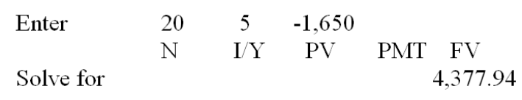

AACSB: Analytic
Bloom's: Application
Difficulty: Intermediate
Learning Objective: 5-1
Section: 5.1
Topic: Simple versus compound interest
24. Travis invested $9,250 in an account that pays 6 percent simple interest. How much more could he have earned over a 7-year period if the interest had compounded annually?
A. $741.41
B. $773.58
C. $802.16
D. $833.33
E. $858.09
Simple interest = $9,250 + ($9,250  .06  7) = $13,135
Compound interest = $9,250  (1 + .06)⁷ = $13,908.58
Difference = $13,908.58 - $13,135 = $773.58
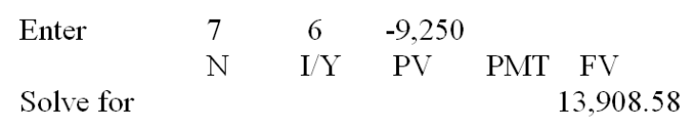

AACSB: Analytic
Bloom's: Application
Difficulty: Intermediate
Learning Objective: 5-1
Section: 5.1
Topic: Simple versus compound interest
25. What is the future value of $7,189 invested for 23 years at 9.25 percent compounded annually?
A. $22,483.60
B. $27,890.87
C. $38,991.07
D. $51,009.13
E. $54,999.88
Future value = $7,189  (1 + .0925)²³ = $54,999.88
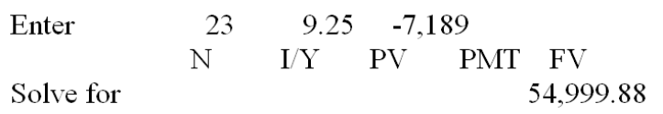

AACSB: Analytic
Bloom's: Application
Difficulty: Basic
Learning Objective: 5-1
Section: 5.1
Topic: Future value
26. Today, you earn a salary of $36,000. What will be your annual salary twelve years from now if you earn annual raises of 3.6 percent?
A. $55,032.54
B. $57,414.06
C. $58,235.24
D. $59,122.08
E. $59,360.45
Future value = $36,000  (1 + .036)¹² = $55,032.54
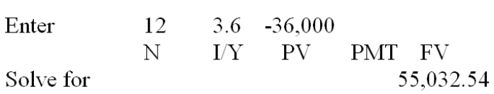

AACSB: Analytic
Bloom's: Application
Difficulty: Basic
Learning Objective: 5-1
Section: 5.1
Topic: Future value
27. You own a classic automobile that is currently valued at $147,900. If the value increases by 6.5 percent annually, how much will the automobile be worth ten years from now?
A. $244,035.00
B. $251,008.17
C. $270,013.38
D. $277,628.63
E. $291,480.18
Future value = $147,900  (1 + .065)¹⁰ = $277,628.63
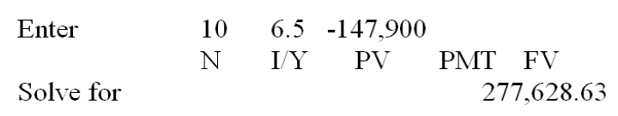

AACSB: Analytic
Bloom's: Application
Difficulty: Basic
Learning Objective: 5-1
Section: 5.1
Topic: Future value
28. You hope to buy your dream car four years from now. Today, that car costs $82,500. You expect the price to increase by an average of 4.8 percent per year over the next four years. How much will your dream car cost by the time you are ready to buy it?
A. $98,340.00
B. $98,666.67
C. $99,517.41
D. $99,818.02
E. $100,023.16
Future value = $82,500  (1 + .048)⁴ = $99,517.41
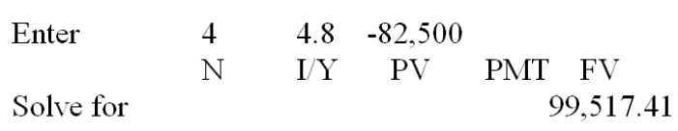

AACSB: Analytic
Bloom's: Application
Difficulty: Basic
Learning Objective: 5-1
Section: 5.1
Topic: Future value
29. This morning, TL Trucking invested $80,000 to help fund a company expansion project planned for 4 years from now. How much additional money will the firm have 4 years from now if it can earn 5 percent rather than 4 percent on its savings?
A. $2,940.09
B. $3,651.82
C. $4,008.17
D. $4,219.68
E. $4,711.08
Future value = $80,000  (1 + .05)⁴ = $97,240.50
Future value = $80,000  (1 + .04)⁴ = $93,588.68
Difference = $97,240.50 - $93,588.68 = $3,651.82
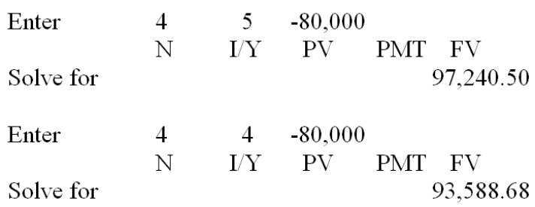

AACSB: Analytic
Bloom's: Analysis
Difficulty: Intermediate
Learning Objective: 5-1
Section: 5.1
Topic: Future value
30. You just received $225,000 from an insurance settlement. You have decided to set this money aside and invest it for your retirement. Currently, your goal is to retire 25 years from today. How much more will you have in your account on the day you retire if you can earn an average return of 10.5 percent rather than just 8 percent?
A. $417,137
B. $689,509
C. $1,050,423
D. $1,189,576
E. $1,818,342
Future value = $225,000  (1 + .105)²⁵ = $2,730,483
Future value = $225,000  (1 + .08)²⁵ = $1,540,907
Difference = $2,730,483 - $1,540,907 = $1,189,576
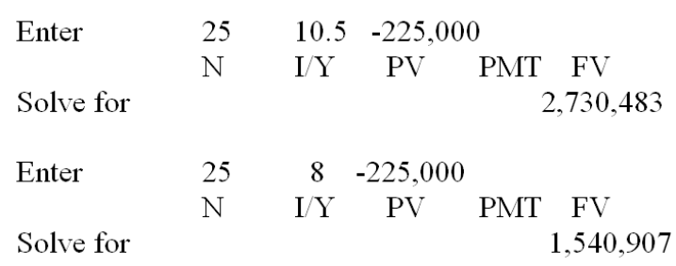

AACSB: Analytic
Bloom's: Analysis
Difficulty: Intermediate
Learning Objective: 5-1
Section: 5.1
Topic: Future value
31. You just received a $5,000 gift from your grandmother. You have decided to save this money so that you can gift it to your grandchildren 50 years from now. How much additional money will you have to gift to your grandchildren if you can earn an average of 8.5 percent instead of just 8 percent on your savings?
A. $47,318.09
B. $52,464.79
C. $55,211.16
D. $58,811.99
E. $60,923.52
Future value = $5,000  (1 + .085)⁵⁰ = $295,431.58
Future value = $5,000  (1 + .08)⁵⁰ = $234,508.06
Difference = $295,431.58 - $234,508.06 = $60,923.52
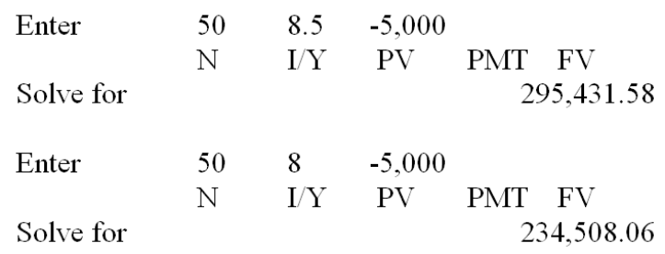

AACSB: Analytic
Bloom's: Analysis
Difficulty: Intermediate
Learning Objective: 5-1
Section: 5.1
Topic: Future value
32. You are depositing $1,500 in a retirement account today and expect to earn an average return of 7.5 percent on this money. How much additional income will you earn if you leave the money invested for 45 years instead of just 40 years?
A. $10,723.08
B. $11,790.90
C. $12,441.56
D. $12,908.19
E. $13,590.93
Future value = $1,500  (1 + .075)⁴⁵ = $38,857.26
Future value = $1,500  (1 + .075)⁴⁰ = $27,066.36
Difference = $38,857.26 - $27,066.36 = $11,790.90
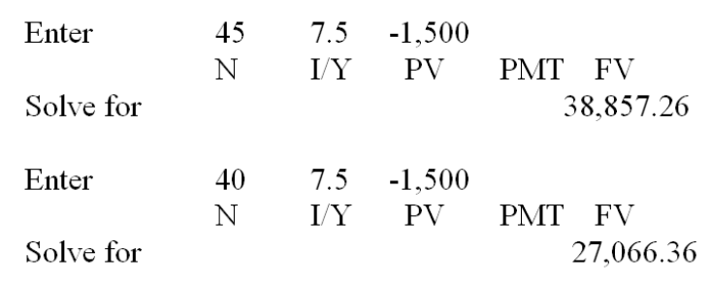

AACSB: Analytic
Bloom's: Analysis
Difficulty: Intermediate
Learning Objective: 5-1
Section: 5.1
Topic: Future value
33. You collect old coins. Today, you have two coins each of which is valued at $250. One coin is expected to increase in value by 6 percent annually while the other coin is expected to increase in value by 4.5 percent annually. What will be the difference in the value of the two coins 15 years from now?
A. $115.32
B. $208.04
C. $241.79
D. $254.24
E. $280.15
Future value = $250  (1 + .06)¹⁵ = $599.14
Future value = $250  (1 + .045)¹⁵ = $483.82
Difference = $599.14 - $483.82 = $115.32
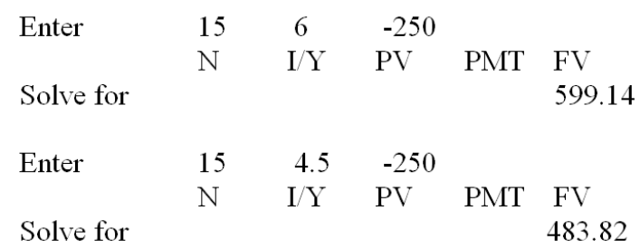

AACSB: Analytic
Bloom's: Analysis
Difficulty: Intermediate
Learning Objective: 5-1
Section: 5.1
Topic: Future value
34. Your father invested a lump sum 26 years ago at 4.25 percent interest. Today, he gave you the proceeds of that investment which totaled $51,480.79. How much did your father originally invest?
A. $15,929.47
B. $16,500.00
C. $17,444.86
D. $17,500.00
E. $17,999.45
Present value = $51,480.79  [1/(1 + .0425)²⁶] = $17,444.86
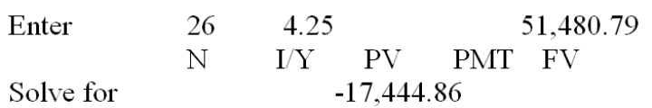

AACSB: Analytic
Bloom's: Application
Difficulty: Basic
Learning Objective: 5-2
Section: 5.2
Topic: Present value
35. What is the present value of $150,000 to be received 8 years from today if the discount rate is 11 percent?
A. $65,088.97
B. $71,147.07
C. $74,141.41
D. $79,806.18
E. $83,291.06
Present value = $150,000  [1/1 + .11)⁸] = $65,088.97
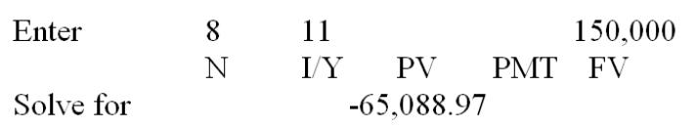

AACSB: Analytic
Bloom's: Application
Difficulty: Basic
Learning Objective: 5-2
Section: 5.2
Topic: Present value
36. You would like to give your daughter $75,000 towards her college education 17 years from now. How much money must you set aside today for this purpose if you can earn 8 percent on your investments?
A. $18,388.19
B. $20,270.17
C. $28,417.67
D. $29,311.13
E. $32,488.37
Present value = $75,000  [1/(1 + .08)¹⁷] = $20,270.17
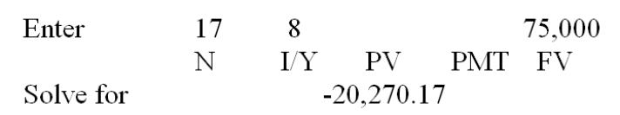

AACSB: Analytic
Bloom's: Application
Difficulty: Basic
Learning Objective: 5-2
Section: 5.2
Topic: Present value
37. You want to have $35,000 saved 6 years from now to buy a house. How much less do you have to deposit today to reach this goal if you can earn 5.5 percent rather than 5 percent on your savings? Today's deposit is the only deposit you will make to this savings account.
A. $733.94
B. $791.18
C. $824.60
D. $845.11
E. $919.02
Present value = $35,000  [1/(1 + .05)⁶] = $26,117.54
Present value = $35,000  [1/(1 + .055)⁶] = $25,383.60
Difference = $26,117.54 - $25,383.60 = $733.94
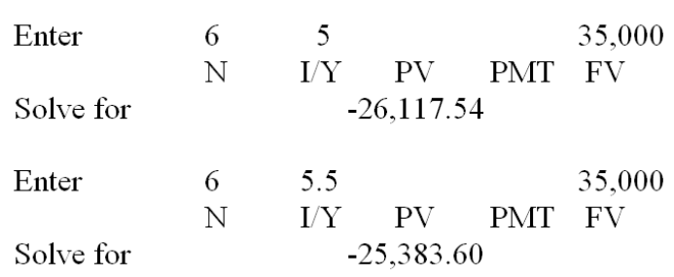

AACSB: Analytic
Bloom's: Application
Difficulty: Intermediate
Learning Objective: 5-2
Section: 5.2
Topic: Present value
38. Your older sister deposited $5,000 today at 8.5 percent interest for 5 years. You would like to have just as much money at the end of the next 5 years as your sister will have. However, you can only earn 7 percent interest. How much more money must you deposit today than your sister did if you are to have the same amount at the end of the 5 years?
A. $321.19
B. $360.43
C. $387.78
D. $401.21
E. $413.39
Future value = $5,000  (1 + .085)⁵ = $7,518.28
Present value = $7,518.28  [1/(1 + .07)⁵] = $5,360.43
Difference = $5,360.43 - $5,000 = $360.43
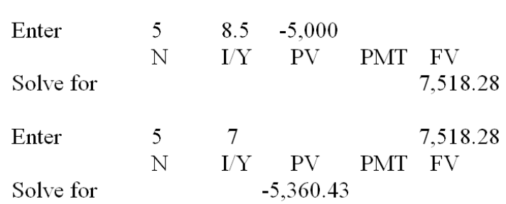

AACSB: Analytic
Bloom's: Analysis
Difficulty: Intermediate
Learning Objective: 5-1 and 5-2
Section: 5.1 and 5.2
Topic: Present and future values
39. A year ago, you deposited $30,000 into a retirement savings account at a fixed rate of 5.5 percent. Today, you could earn a fixed rate of 6.5 percent on a similar type account. However, your rate is fixed and cannot be adjusted. How much less could you have deposited last year if you could have earned a fixed rate of 6.5 percent and still have the same amount as you currently will when you retire 38 years from today?
A. $2,118.42 less
B. $3,333.33 less
C. $5,417.09 less
D. $7,274.12 less
E. $9,234.97 less
Future value = $30,000  (1 + .055)³⁸⁺¹ = $242,084.61
Present value = $242,084.61  [1/(1 + .065)³⁸⁺¹] = $20,765.03
Difference = $30,000 - $20,765.03 = $9,234.97
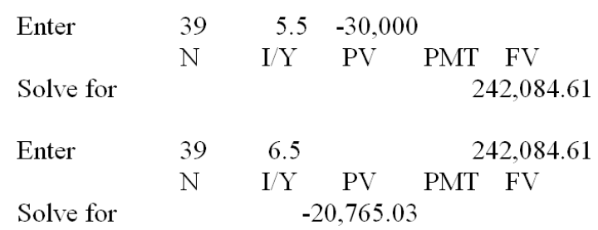

AACSB: Analytic
Bloom's: Analysis
Difficulty: Intermediate
Learning Objective: 5-1 and 5-2
Section: 5.1 and 5.2
Topic: Present and future values
40. When you retire 40 years from now, you want to have $1.2 million. You think you can earn an average of 12 percent on your investments. To meet your goal, you are trying to decide whether to deposit a lump sum today, or to wait and deposit a lump sum 2 years from today. How much more will you have to deposit as a lump sum if you wait for 2 years before making the deposit?
A. $1,414.14
B. $2,319.47
C. $2,891.11
D. $3,280.78
E. $3,406.78
Present value = $1,200,000  [1/(1 + .12)⁴⁰] = $12,896.16
Present value = $1,200,000  [1/(1 + .12)³⁸] = $16,176.94
Difference = $16,176.94 - $12,896.16 = $3,280.78
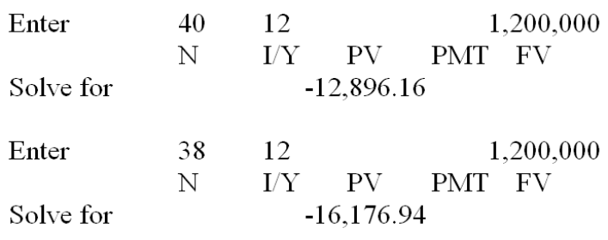

AACSB: Analytic
Bloom's: Analysis
Difficulty: Intermediate
Learning Objective: 5-2
Section: 5.2
Topic: Present value
41. Theo needs $40,000 as a down payment for a house 6 years from now. He earns 3.5 percent on his savings. Theo can either deposit one lump sum today for this purpose or he can wait a year and deposit a lump sum. How much additional money must he deposit if he waits for one year rather than making the deposit today?
A. $878.98
B. $911.13
C. $1,138.90
D. $1,348.03
E. $1,420.18
Present value = $40,000  [1/(1 + .035)⁶] = $32,540.03
Present value = $26,000  [1/(1 + .035)⁵] = $33,678.93
Difference = $33,678.93 - $32,540.03 = $1,138.90
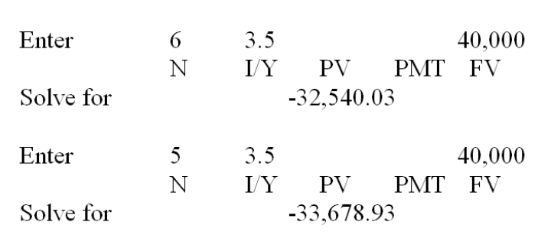

AACSB: Analytic
Bloom's: Analysis
Difficulty: Intermediate
Learning Objective: 5-2
Section: 5.2
Topic: Present value
42. One year ago, you invested $1,800. Today it is worth $1,924.62. What rate of interest did you earn?
A. 6.59 percent
B. 6.67 percent
C. 6.88 percent
D. 6.92 percent
E. 7.01 percent
$1,924.62 = $1,800  (1 + r)¹; r = 6.92 percent
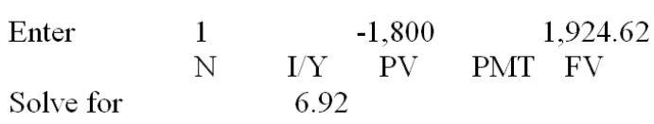

AACSB: Analytic
Bloom's: Application
Difficulty: Basic
Learning Objective: 5-3
Section: 5.3
Topic: Interest rate
43. According to the Rule of 72, you can do which one of the following?
A. double your money in five years at 7.2 percent interest
B. double your money in 7.2 years at 8 percent interest
C. double your money in 8 years at 9 percent interest
D. triple your money in 7.2 years at 5 percent interest
E. triple your money at 10 percent interest in 7.2 years
Rule of 72 = 72/8 years = 9 percent interest

AACSB: Analytic
Bloom's: Application
Difficulty: Basic
Learning Objective: 5-3
Section: 5.3
Topic: Interest rate
44. Forty years ago, your mother invested $5,000. Today, that investment is worth $430,065.11. What is the average annual rate of return she earned on this investment?
A. 11.68 percent
B. 11.71 percent
C. 11.78 percent
D. 11.91 percent
E. 12.02 percent
$430,065.11 = $5,000  (1 + r)⁴⁰; r = 11.78 percent
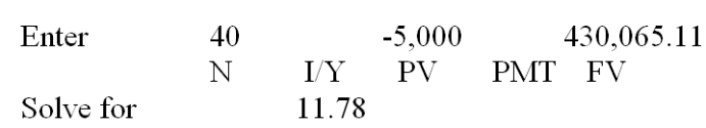

AACSB: Analytic
Bloom's: Application
Difficulty: Basic
Learning Objective: 5-3
Section: 5.3
Topic: Interest rate
45. Sixteen years ago, Alicia invested $1,000. Eight years ago, Travis invested $2,000. Today, both Alicia's and Travis' investments are each worth $2,400. Assume that both Alicia and Travis continue to earn their respective rates of return. Which one of the following statements is correct concerning these investments?
A. Three years from today, Travis' investment will be worth more than Alicia's.
B. One year ago, Alicia's investment was worth less than Travis' investment.
C. Travis earns a higher rate of return than Alicia.
D. Travis has earned an average annual interest rate of 3.37 percent.
E. Alicia has earned an average annual interest rate of 6.01 percent.
Alicia: $2,400 = $1,000  (1 + r)¹⁶; r = 5.62 percent
Travis: $2,400 = $2,000  (1 + r)⁸; r = 2.31 percent
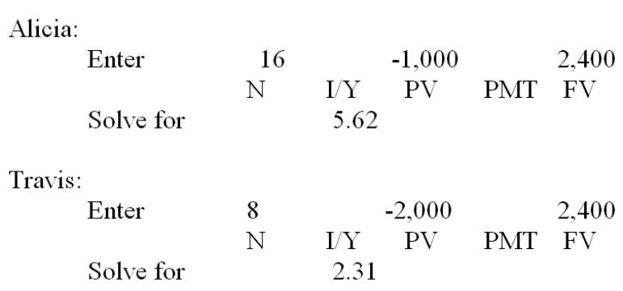
Since both Alicia and Travis have equal account values today and since Alicia earns the higher rate of return, her account had to be worth less than Travis' account one year ago.

AACSB: Analytic
Bloom's: Synthesis
Difficulty: Intermediate
Learning Objective: 5-3
Section: 5.3
Topic: Interest rate
46. Penn Station is saving money to build a new loading platform. Two years ago, they set aside $24,000 for this purpose. Today, that account is worth $28,399. What rate of interest is Penn Station earning on this investment?
A. 6.39 percent
B. 7.47 percent
C. 8.78 percent
D. 9.23 percent
E. 9.67 percent
$28,399 = $24,000  (1 + r)²; r = 8.78 percent
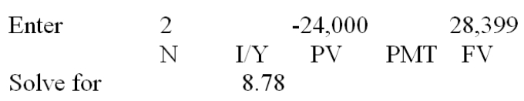

AACSB: Analytic
Bloom's: Analysis
Difficulty: Basic
Learning Objective: 5-3
Section: 5.3
Topic: Interest rate
47. Fifteen years ago, Jackson Supply set aside $130,000 in case of a financial emergency. Today, that account has increased in value to $330,592. What rate of interest is the firm earning on this money?
A. 5.80 percent
B. 6.42 percent
C. 6.75 percent
D. 7.28 percent
E. 7.53 percent
$330,592 = $130,000  (1 + r)¹⁵; r = 6.42 percent
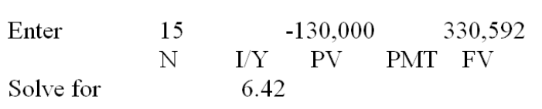

AACSB: Analytic
Bloom's: Application
Difficulty: Basic
Learning Objective: 5-3
Section: 5.3
Topic: Interest rate
48. Fourteen years ago, your parents set aside $7,500 to help fund your college education. Today, that fund is valued at $26,180. What rate of interest is being earned on this account?
A. 7.99 percent
B. 8.36 percent
C. 8.51 percent
D. 9.34 percent
E. 10.06 percent
$26,180 = $7,500  (1 + r)¹⁴; r = 9.34 percent
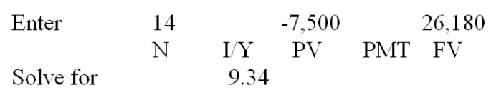

AACSB: Analytic
Bloom's: Application
Difficulty: Basic
Learning Objective: 5-3
Section: 5.3
Topic: Interest rate
49. Some time ago, Julie purchased eleven acres of land costing $36,900. Today, that land is valued at $214,800. How long has she owned this land if the price of the land has been increasing at 10.5 percent per year?
A. 13.33 years
B. 16.98 years
C. 17.64 years
D. 19.29 years
E. 21.08 years
$214,800 = $36,900  (1 + .105)^{t}; t = 17.64 years
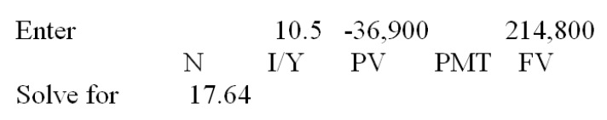

AACSB: Analytic
Bloom's: Application
Difficulty: Basic
Learning Objective: 5-4
Section: 5.3
Topic: Time period
50. On your ninth birthday, you received $300 which you invested at 4.5 percent interest, compounded annually. Your investment is now worth $756. How old are you today?
A. age 29
B. age 30
C. age 31
D. age 32
E. age 33
$756 = $300  (1 + .045)^{t}; t = 21 years; Age today = 9 + 21 = 30
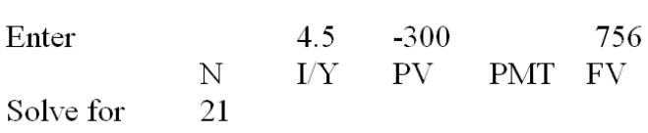

AACSB: Analytic
Bloom's: Application
Difficulty: Basic
Learning Objective: 5-4
Section: 5.3
Topic: Time period

Essay Questions
51. You want to deposit sufficient money today into a savings account so that you will have $1,000 in the account three years from today. Explain why you could deposit less money today if you could earn 3.5 percent interest rather than 3 percent interest.
Student answers will vary but should present the idea that when you can earn more interest, you need less of your own money to reach the same future dollar amount. They can also base their answer on the present value formula.
Feedback: Refer to section 5.2

AACSB: Reflective thinking
Bloom's: Analysis
Difficulty: Basic
Learning Objective: 5-2
Section: 5.2
Topic: Present value
52. You are considering two separate investments. Both investments pay 7 percent interest. Investment A pays simple interest and Investment B pays compound interest. Which investment should you choose, and why, if you plan on investing for a period of 5 years?
Simple interest is interest earned on the initial principal amount only. Compound interest is interest earned on both the initial principal and all prior interest earnings that have been reinvested. You should choose Investment B which pays compound interest as you will earn more interest income over the 5 years by doing so.
Feedback: Refer to section 5.1

AACSB: Reflective thinking
Bloom's: Analysis
Difficulty: Basic
Learning Objective: 5-1
Section: 5.1
Topic: Simple and compound interest
53. What lesson does the future value formula provide for young workers who are looking ahead to retiring some day?
The future value formula is: FV = PV (1 + r)^{t}. Time is the exponent. While the rate of return is important and has a direct affect on the growth of an investment account, time is critical. To maximize retirement income, workers need to commence saving when they are young so that reinvested earnings have time to compound.
Feedback: Refer to section 5.1

AACSB: Reflective thinking
Bloom's: Evaluation
Difficulty: Intermediate
Learning Objective: 5-1
Section: 5.1
Topic: Future value
54. You are considering two lottery payment options: Option A pays $10,000 today and Option B pays $20,000 at the end of ten years. Assume you can earn 6 percent on your savings. Which option will you choose if you base your decision on present values? Which option will you choose if you base your decision on future values? Explain why your answers are either the same or different.
PV of A = $10,000; PV of B = $11,167.90; FV of A = $17,908.48; FV of B = $20,000. Based on both present values and future values, B is the better choice. Students should explain that computing present values and computing future values are simply inverse processes of one another, and that choosing between two lump sums based on present values will always give the same result as choosing between the same two lump sums based on future values.
Feedback: Refer to sections 5.1 and 5.2

AACSB: Reflective thinking
Bloom's: Evaluation
Difficulty: Intermediate
Learning Objective: 5-1 and 5-2
Section: 5.1 and 5.2
Topic: Present and future values
55. At an interest rate of 10 percent and using the Rule of 72, how long will it take to double the value of a lump sum invested today? How long will it take after that until the account grows to four times the initial investment? Given the power of compounding, shouldn't it take less time for the money to double the second time?
It will take 7.2 years to double the initial investment, then another 7.2 years to double it again. That is, it takes 14.4 years for the value to reach four times the initial investment. Compounding doesn't affect the amount of time it takes for an investment to double in value. However, you should note that during the first 7.2 years, the interest earned is equal to 100 percent of the initial investment. During the second 7.2 years, the interest earned is equal to 200 percent of the initial investment. That is the power of compounding.
Feedback: Refer to section 5.3

AACSB: Reflective thinking
Bloom's: Analysis
Difficulty: Intermediate
Learning Objective: 5-4
Section: 5.3
Topic: Rule of 72

Multiple Choice Questions
56. Assume the total cost of a college education will be $300,000 when your child enters college in 16 years. You presently have $75,561 to invest. What rate of interest must you earn on your investment to cover the cost of your child's college education?
A. 7.75 percent
B. 8.50 percent
C. 9.00 percent
D. 9.25 percent
E. 9.50 percent
$300,000 = $75,561 (1 + r)¹⁶; r = 9 percent
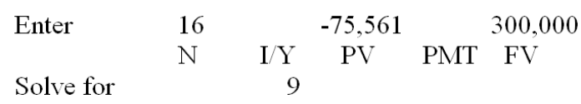

AACSB: Analytic
Bloom's: Application
Difficulty: Basic
EOC #: 5-6
Learning Objective: 5-3
Section: 5.3
Topic: Interest rate
57. At 11 percent interest, how long would it take to quadruple your money?
A. 6.55 years
B. 6.64 years
C. 13.09 years
D. 13.28 years
E. 13.56 years
$4 = $1  (1 + .11)^{t}; t = 13.28 years
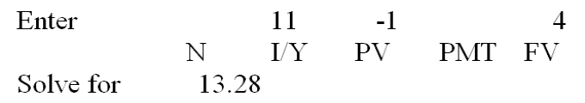

AACSB: Analytic
Bloom's: Application
Difficulty: Basic
Learning Objective: 5-4
Section: 5.3
Topic: Time period
58. Assume the average vehicle selling price in the United States last year was $41,996. The average price 9 years earlier was $29,000. What was the annual increase in the selling price over this time period?
A. 3.89 percent
B. 4.20 percent
C. 4.56 percent
D. 5.01 percent
E. 5.40 percent
$41,996 = $29,000  (1 + r)⁹; r = 4.20 percent
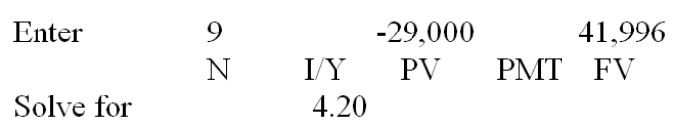

AACSB: Analytic
Bloom's: Application
Difficulty: Basic
EOC #: 5-8
Learning Objective: 5-3
Section: 5.3
Topic: Interest rate
59. You're trying to save to buy a new $160,000 Ferrari. You have $56,000 today that can be invested at your bank. The bank pays 6 percent annual interest on its accounts. How many years will it be before you have enough to buy the car? Assume the price of the car remains constant.
A. 16.67 years
B. 17.04 years
C. 17.41 years
D. 17.87 years
E. 18.02 years
$160,000 = $56,000  (1 + .06)^{t}; t = 18.02 years
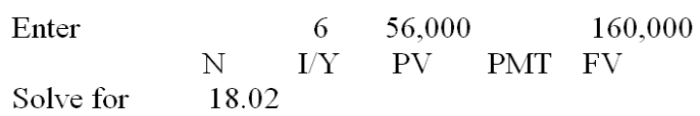

AACSB: Analytic
Bloom's: Application
Difficulty: Basic
EOC #: 5-9
Learning Objective: 5-4
Section: 5.3
Topic: Time period
60. Imprudential, Inc. has an unfunded pension liability of $850 million that must be paid in 25 years. To assess the value of the firm's stock, financial analysts want to discount this liability back to the present. The relevant discount rate is 6.5 percent. What is the present value of this liability?
A. $159,803,162
B. $171,438,907
C. $176,067,311
D. $184,519,484
E. $191,511,367
PV = $850,000,000  [1/(1.065)²⁵] = $176,067,311
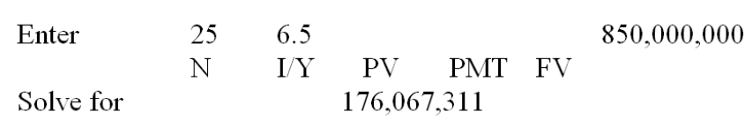

AACSB: Analytic
Bloom's: Application
Difficulty: Basic
EOC #: 5-10
Learning Objective: 5-2
Section: 5.2
Topic: Present value
61. You have just received notification that you have won the $1.4 million first prize in the Centennial Lottery. However, the prize will be awarded on your 100th birthday, 70 years from now. The appropriate discount rate is 8 percent. What is the present value of your winnings?
A. $4,288.16
B. $6,404.20
C. $15,309.91
D. $23,333.33
E. $25,000.00
PV = $1,400,000  [1/(1.08)⁷⁰] = $6,404.20
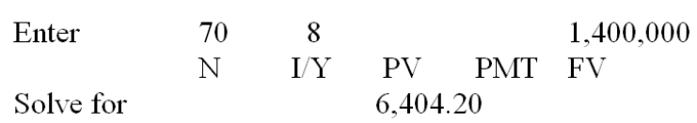

AACSB: Analytic
Bloom's: Application
Difficulty: Basic
EOC #: 5-11
Learning Objective: 5-2
Section: 5.2
Topic: Present value
62. Your coin collection contains fifty-four 1941 silver dollars. Your grandparents purchased them for their face value when they were new. These coins have appreciated at a 10 percent annual rate. How much will your collection be worth when you retire in 2060?
A. $3,611,008
B. $3,987,456
C. $4,122,394
D. $4,421,008
E. $4,551,172
FV = $54  (1.10)¹¹⁹ = $4,551,172
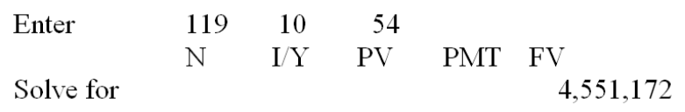

AACSB: Analytic
Bloom's: Application
Difficulty: Basic
EOC #: 5-12
Learning Objective: 5-1
Section: 5.1
Topic: Future value
63. In 1895, the winner of a competition was paid $110. In 2006, the winner's prize was $70,000. What will the winner's prize be in 2040 if the prize continues increasing at the same rate?
A. $389,400
B. $421,122
C. $479,311
D. $505,697
E. $548,121
$70,000 = $110  (1 = r)¹¹¹; r = 5.988466 percent
FV = $70,000  (1 + .05988466)³⁴ = $505,697
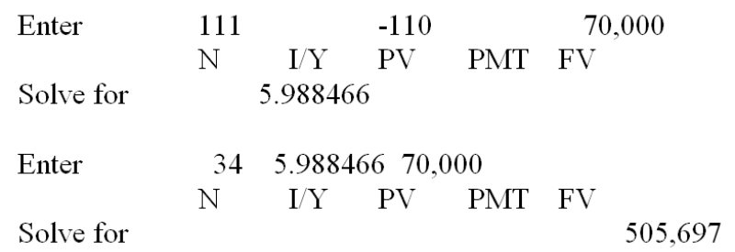

AACSB: Analytic
Bloom's: Analysis
Difficulty: Basic
EOC #: 5-13
Learning Objective: 5-1 and 5-3
Section: 5.1 and 5.3
Topic: Interest rate and future value
64. Suppose that the first comic book of a classic series was sold in 1954. In 2000, the estimated price for this comic book in good condition was about $340,000. This represented a return of 27 percent per year. For this to be true, what was the original price of the comic book in 1954?
A. $5.00
B. $5.28
C. $5.50
D. $5.71
E. $6.00
PV = $340,000  [1/(1 + .27)⁴⁶; PV = $5.71
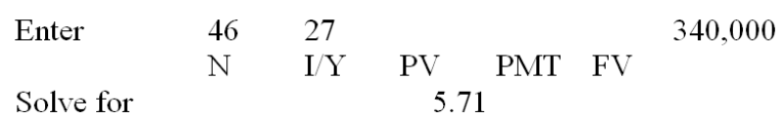

AACSB: Analytic
Bloom's: Application
Difficulty: Intermediate
EOC #: 5-14
Learning Objective: 5-2
Section: 5.2
Topic: Present value
65. Suppose you are committed to owning a $140,000 Ferrari. You believe your mutual fund can achieve an annual rate of return of 9 percent and you want to buy the car in 7 years. How much must you invest today to fund this purchase assuming the price of the car remains constant?
A. $74,208.16
B. $76,584.79
C. $77,911.08
D. $78,019.82
E. $79,446.60
PV = $140,000  [1/(1 + .09)⁷; PV = $76,584.79
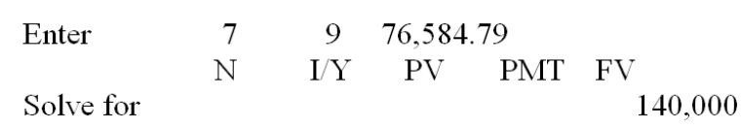

AACSB: Analytic
Bloom's: Application
Difficulty: Intermediate
EOC #: 5-17
Learning Objective: 5-2
Section: 5.2
Topic: Present value
66. You have just made a $1,500 contribution to your individual retirement account. Assume you earn a 12 percent rate of return and make no additional contributions. How much more will your account be worth when you retire in 25 years than it would be if you waited another 10 years before making this contribution?
A. $8,306.16
B. $9,658.77
C. $16,311.18
D. $16,907.17
E. $17,289.75
FV = $1,500  (1 + .12)²⁵ = $25,500.10
FV = $1,500  (1 + .12)¹⁵ = $8,210.35
Difference = $17,289.75
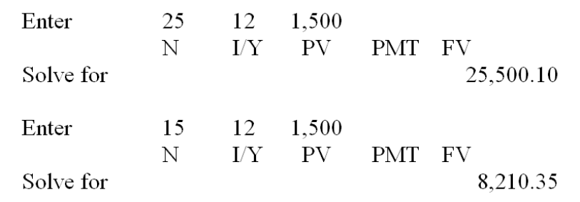

AACSB: Analytic
Bloom's: Application
Difficulty: Intermediate
EOC #: 5-18
Learning Objective: 5-1
Section: 5.1
Topic: Future value
67. You are scheduled to receive $30,000 in two years. When you receive it, you will invest it for 5 more years, at 8 percent per year. How much money will you have 7 years from now?
A. $39,909.19
B. $41,381.16
C. $44,079.84
D. $47,209.19
E. $51,414.73
FV = $30,000  (1 + .08)⁽⁷⁻²⁾ = $44,079.84
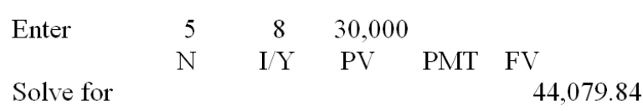

AACSB: Analytic
Bloom's: Application
Difficulty: Intermediate
EOC #: 5-19
Learning Objective: 5-1
Section: 5.1
Topic: Future value
68. You expect to receive $9,000 at graduation in 2 years. You plan on investing this money at 10 percent until you have $60,000. How many years will it be until this occurs?
A. 18.78 years
B. 19.96 years
C. 21.90 years
D. 23.08 years
E. 25.00 years
$60,000 = $9,000  (1 + .10)^{t}; t = 19.90 years
Total time = 2 + 19.90 = 21.90 years
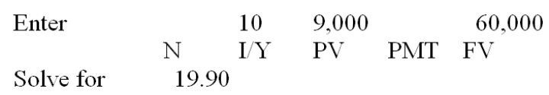

AACSB: Analytic
Bloom's: Application
Difficulty: Intermediate
EOC #: 5-20
Learning Objective: 5-4
Section: 5.3
Topic: Time period

